**DELIVERABLE 1- PROPOSAL**

**Project Title:**

Android Women safety app

**Group Name:**

Softwareengineering_project

**Group Members:**

1. Krishna Sai Ujwal Kambhpati (Group Leader)
2. Sharan Kumar Pallapu
3. Vineesha Sangepu
4. Praveen Reddy Talupu

5. Vineela Pamarthi

6. Jayakanth Madineni

7. Sai Tai Prathyusha Garikapati

**Project Description:**

It is dangerous to go out at night, particularly if you're a woman in today's environment, it’s long past time for women to stop travelling alone, because they can't defend themselves as well as males can. In order to lessen the likelihood of being a victim of violent crime we need something that can help them in difficult times. Women can use this application to protect themselves in the time of danger and this application lets the user to not only alert the emergency contact but also to share the location of the user to let the other person track the user. The main motivation of this application is to help women in an unwanted situation.

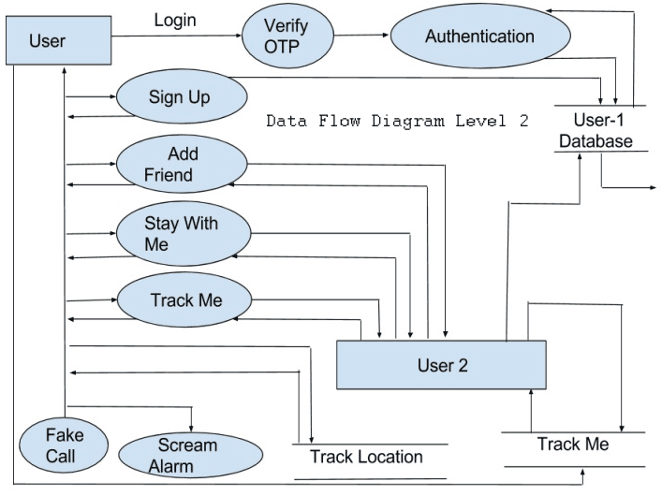

**Development Environment**

The following are the hardware and software requirement used to develop this application.

1. **Hardware Requirements:**

* Intel i5 process and above
* RAM 8 GB and above
* HD 100 GB and above
* GPU GTX 1080 and above

1. **Software Requirements:**

* IDE : Android studio
* Front End Language: XML
* Back End Language: Java, Android

**Project Timeline:**

The project timeline consists of Modules, Functionalities, planning and Gantt Chart of the project.

**Modules / Features of Project**

1. **Detailed instruction page**

This page consists all the instructions of the app. It helps user to understand the functionality of the app and helps them how to use the app.

1. **Add contact detail**

In this module, the user can add the contact detail of the person whom they want to put as emergency contact. By clicking on add contact detail, user can enter the mobile number.

1. **Remove contact**

In this module, user can delete or remove the saved contact details which helps the user to change the emergency contact by removing and adding a new one.

1. **Add profile name**

This function helps the user to add a name to their profile which will help the user to identify themselves.

1. **Emergency contact number calling feature**

This feature enables the user to call the emergency contact number by clicking on the button.

1. **SOS button**

This feature is used to send a message to the emergency contact by clicking on the SOS button. We can send a default message which will lessen the time.

1. **Live location tracking button**

This module is implemented to let the user share their live location which will help the emergency contact to track the user**.**

1. **Emergency contact message sharing button.**

* The project can be installed in large women population phones to support tracking.
* The System admin will be able to run real time and give support if required.

**Functional Requirements**

* The messaging app's functionality is dissected, and our findings are presented. Unless they actively ask for help, they will only be contacted via the means they currently have on file.
* Using SMS tracking updates, the victim's exact position may be identified rapidly and securely. The motivation for this idea is the need to ensure the safety of women.
* To that end, it is important to take into account the specific dangers faced by modern women. With all of the safeguards in place, women can be certain that they will never be placed in harm's way. system.

**Project Timeline:**

**GANTT Chart:**

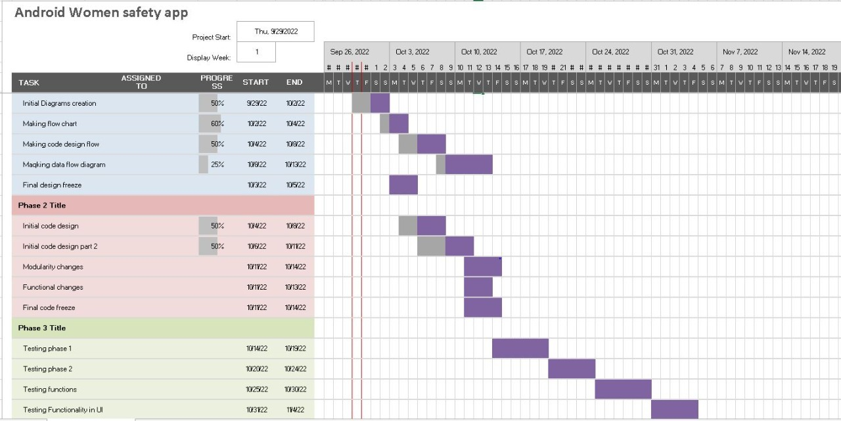

**Risk Management:**

In our group discussion while analysing the project requirements we identified the following major risks.

1.Lack of knowledge in java programming for few members in team to accomplish certain tasks

2.Unable to work on non-internet locations.

3.Accuracy needs improvement

4.Developing an application by a group of people at different timings and schedules will lead to delay in achieving tasks and deliverables.

**Team Roles:**

* Krishna Sai Ujwal Kambhpati (Group Leader): Design of the UI, the design of user experiences
* Vineesha Sangepu: Creation of flow diagrams and code optimisation
* Praveen Reddy Talupu: Designing backend
* Vineela Pamarthi: Designing of documentation , content creation
* Jayakanth Madineni : Logic development and backend
* Sharan Kumar Pallapu: Server connection and documentation
* Sai Tai Prathyusha Garikapati: Connecting teams and frontend designs

**Member Contribution Table (For Deliverable 1):**

|  |  |  |  |
| --- | --- | --- | --- |
| Member Name | Contribution Description | Overall Contribution | Note |
| Krishna Sai Ujwal Kambhpati | Design of the UI, the design of user experiences  Being leader of the team, I have discussed project ideas with team and also attended zoom meetings to work for the deliverable. | 14% |  |
| Vineesha Sangepu | Creation of flow diagrams and code optimisation. I have worked on proposing the project ideas and deciding on one. I am involved in planning and deciding a schedule for the coming weeks. | 14% |  |
| Praveen Reddy Talupu | Designing backend. I have attended the zoom meetings and discussed about the functionalities and modules that are to be included in the project. | 12% |  |
| Vineela Pamarthi | Designing of documentation , content creation. I have also worked on creating github readme file and on the meeting minutes file. | 12% |  |
| Jayakanth Madineni | Logic development and backend. I have worked on preparing the ppt presentation, creating the gantt chart and contributed my ideas for the risk management. | 12% |  |
| Sharan kumar pallapu | Server connection and documentation. I have also worked on gantt chart and gathered the information required for modules. I have made the final changes to the ppt. | 12% |  |
| Sai Tai Prathyusha Garikapati | Connecting teams and frontend designs.  I have shared few ideas about the implementing and working of few modules and helped submitting few documents in canvas. | 12% |  |